QUESTION 2
You are working as a junior system administrator responsible for organizing project-related files in your home directory. Your supervisor wants you to demonstrate your understanding of Linux file and directory management commands.
- Project Workspace Setup: Create a directory named documents inside your home directory. This directory will store your project-related files.
Answer 1: To create the documents directory in my home directory, I used the mkdir command. The tilde (~) symbol is a shortcut for the home directory. I have used the ls command to show that the directory has been created.
Command: mkdir ~/documents
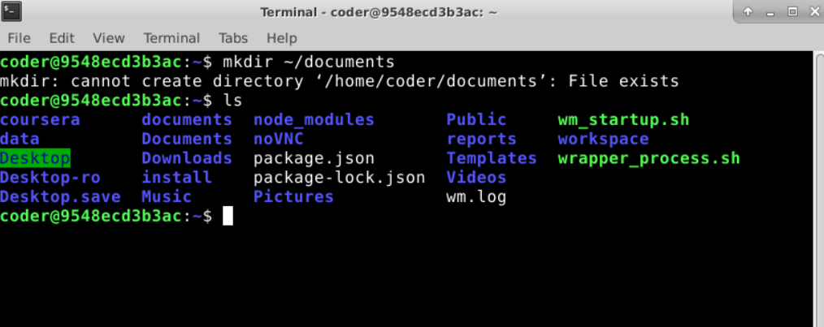
- File Creation: Navigate into the documents directory and create a file named plan.txt.
Answer 2: I navigated into the new directory using cd (change directory) and then created the plan.txt file using the touch command.
Command: cd ~/documents & touch plan.txt
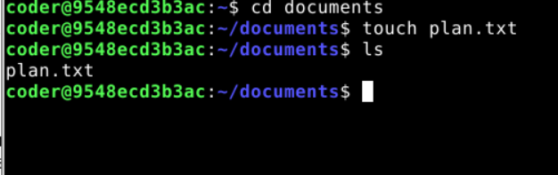
- Content Addition: Write some sample text of your choice into the plan.txt file. The content can be a short project note or reminder.
Answer 3: To add text to the file, I used the echo command with the > redirection symbol, which sends the text into the file.
Command: echo "Reminder to complete the YouTube script on the story behind the first computer worm" > plan.txt
- File Metadata Verification: Display the permissions and ownership details of the plan.txt file. Ensure your username appears in the output.
Answer 4: To view the permissions, owner, and group details, I used ls -l (long format listing). The username in my system, which is "coder", appears on the output.
Command: ls -l plan.txt
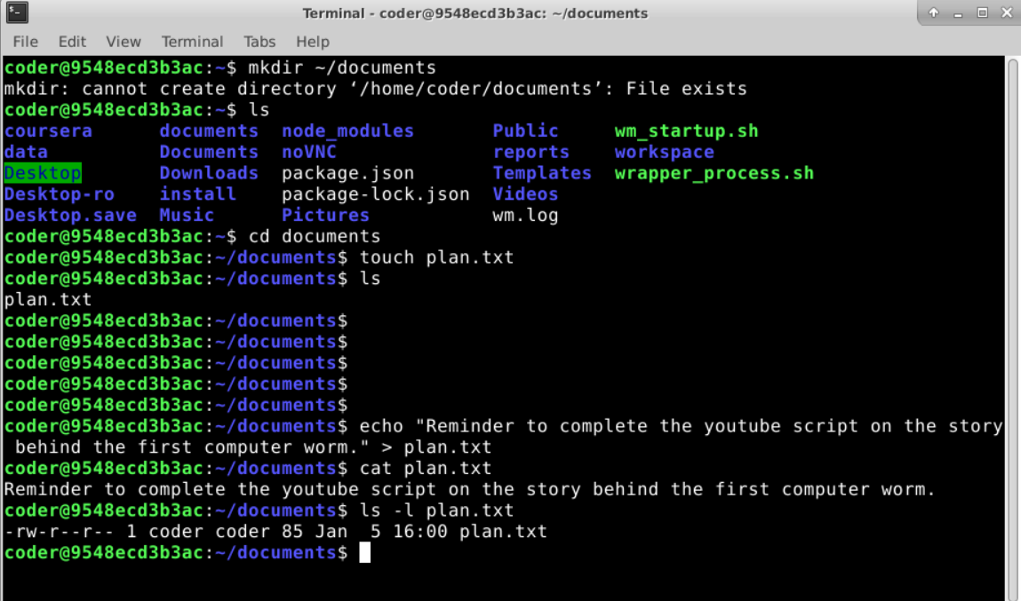
- File Duplication: Create a copy of plan.txt and name it plan_copy.txt.
Answer 5: I used the cp (copy) command to create a duplicate of the plan.txt file.
Command: cp plan.txt plan_copy.txt
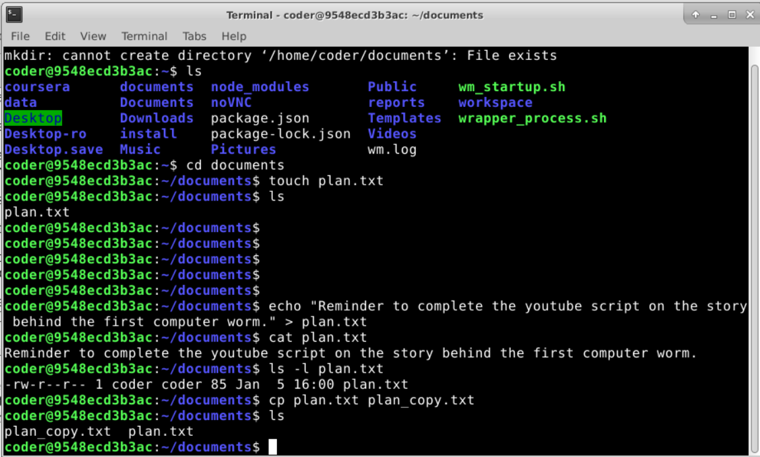
- Directory Renaming: Rename the documents directory to project_documents to reflect the project scope more clearly.
Answer 6: The mv (move) command is used for both moving and renaming files or directories. Therefore, I used the mv command with the directory names. I was in the directory that was being renamed, so I went back using cd .. and then used the ls command to check if the name had been changed. The name was changed successfully. Then I used cd with the directory name to go back inside the directory to do the further questions.
Command: mv ~/documents ~/project_documents
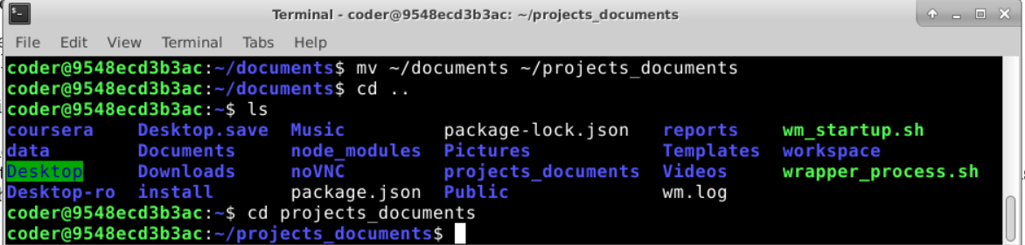
- Archival Structure: Inside the project_documents directory, create a subdirectory named archive.
Answer 7: After navigating into the renamed directory, I used mkdir again to create the archive subdirectory. Then used ls to check if it had been created. The sub-directory had been successfully created.
Command: mkdir archive
